- Name, Team Members
Movie Rating Prediction and Influential Factors Analysis Based on TMDB Data

- Short Description
This project uses the TMDB API to create a movie data analysis workflow to acquire movie data. It can automatically retrieve movie metadata from multiple pages, such as title, release year, rating, genre, director, and cast, primarily focusing on popular films. The project aims to collect movie information in a structured manner, writing it into a CSV file for subsequent work. Analysis can be performed from perspectives such as movie popularity, rating, genre, and the number of films the actor/director has appeared in. This is beneficial for researching movie trends, recommending movies, and understanding the film market.
- Data
（1）Data Sources
Source Type | Description
TMDB Movie API | Used to get raw movie metadata such as rating, vote_count, release_date, cast, directors, popularity, runtime, etc.
（2）Data Columns
Column Name | Description
id | Unique identifier for each movie (Primary Key).
title | Official title of the movie.
release_date | Date when the movie was released (format: YYYY-MM-DD).
vote_average | Average user rating scored on a 0–10 scale.
vote_count | Number of individual user votes contributing to the rating.
popularity | Popularity index generated by TMDB based on user activity and interactions.
runtime | Duration of the movie in minutes.
genres | List of genres assigned to the movie (e.g., Action, Fantasy, Comedy).
directors | List of directors associated with the movie.
cast | Leading cast members (typically top-billed actors).
（3）Data Samples
- Data Cleaning, Analysis & Visualization
Before analyzing, I first cleaned and organized the movie data obtained from TMDB. The raw data contained information like date, rating, popularity, genre, director, and actors, but some fields had different formats. For instance, the genres, directors, and cast were all strings, not lists. So, I turned it into a form that can be iterated over for doing statistics. Also release_date was changed to time format to prevent error in time. Then I checked for missing data and dropped records without core numericals like popularity, # of votes, and movie length to avoid any potential bias in the model-training stage caused by absent values. And finally, we had a well-formed dataset with useful variables that met the needs of our further analysis.
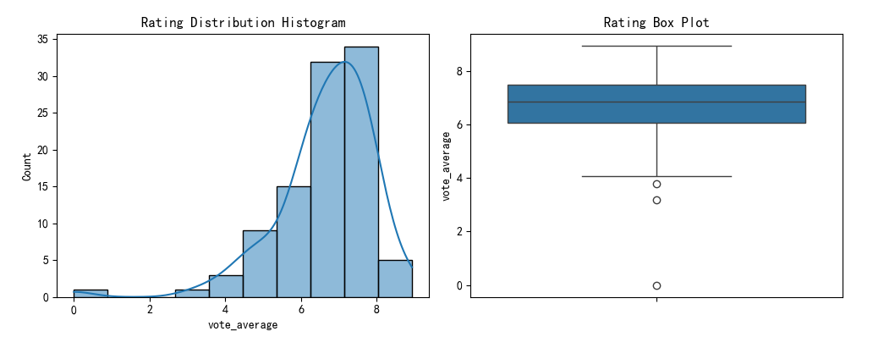
I begin to analyze my data after cleaned it. Starting off with the rating distribution, histograms and box plots showed that most of the film ratings were clustered around the 6 to 8 point range, so most films got good reviews from people watching them, not super positive or super negative. Then I figured out how many times each film genre came up and made a bar graph. From the results, we can see that action, thriller and sci-fi film types have the largest proportions, meaning that these genres are more commercially mature with a larger amount of films produced. But the high-frequency songs are not all highly praised, and this was confirmed in later analysis.
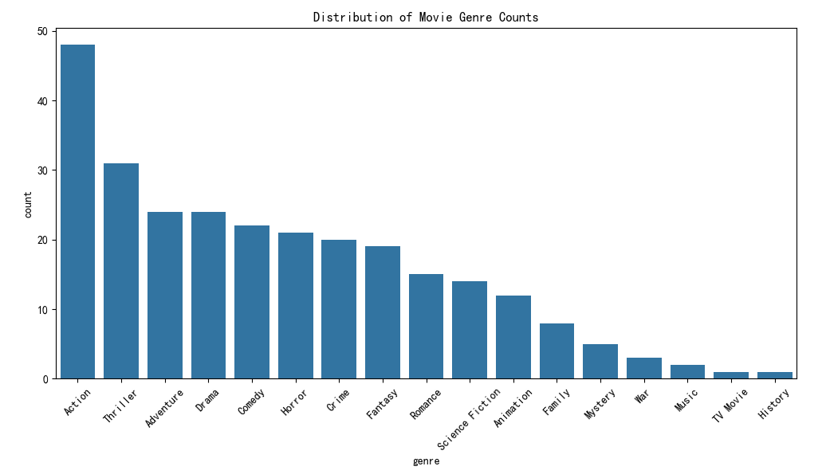
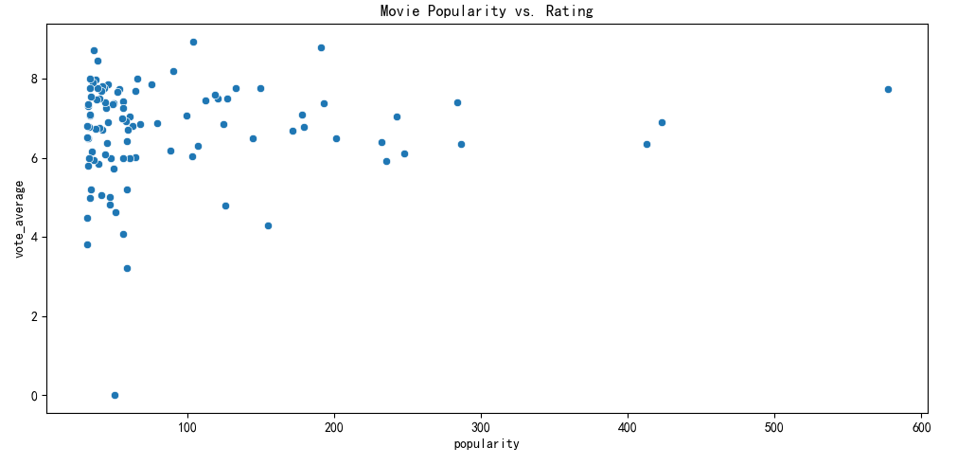
To know which parts of the films are related to the ratings, I get the correlations between the ratings and different numbers of the films. Then, I used a scatterplot to show how these movie’s popularity affects the movie's ratings. There is a positive association between how popular something is and the ratings, but this is very spread out which means that popular things generally have good reputations, but not everything that is popular is also respected.

After finishing all the visualizations, I made some analytical hypotheses about the model according to the comprehensive visualization. This project assumes from the start that a film's rating is related to its popularity; that is, films that are more popular and receive a greater number of votes will be given higher ratings. And also to see if a films genre, or run time affects its rating. In the end, it can be seen that the number of votes and popularity have a greater influence on the ratings than film runtime and film genre distribution. In general, it has been shown that audiences engagement and audiences’ attention are key drivers behind changing ratings, which sets the stage for the rest of the models and analyses.
- Changes from Original Proposal
During the project, some parts of the research plan were modified. Initially, I wanted more data to allow for more feature variables and more detailed analysis. However, during data collection, I discovered some expected fields were missing, had different formats, or were inaccessible. Continuing with the previous methods would reduce the accuracy and readability of the results. Therefore, to ensure the quality of the analysis, the data scope was appropriately narrowed, time permitting. Some valuable and meaningful indicators were retained, and more time was spent on data cleaning to ensure data quality. Additionally, my initial plan included making more complex predictions and building models. However, due to the high cost of training and parameter tuning, data analysis and visualization methods were used to make the data clearer and easier to understand, thus making the entire research process more complete.
- Mention of Future Work
Even though the data collection of this project is done well, as well as the data cleaning and visualisation of the data. But I think there is still a need for improvement and expansion. In the future, if there is more time or more computing resources, I would like to try the following things: The first thing is to increase the scale of the data, such as increasing the number of years of data, or adding more film platforms. this way, it will be more thorough and representative. Second, this article is also a kind of visualization, analysis and analysis, which can be used in the future with some machine learning model, or deep learning model like the box office prediction, rating prediction, or similar movie recommendation to do some intelligent analysis. Moreover, we can do more textual analysis like the text sentiment analysis based on films’ reviews, we can analyze the relationship of audience’s sentiments and rating, and thus reach more explanatory conclusions. And it can also become a dynamic data visualization system, allowing people to choose the different types of films, different film years, and different film directors for dynamic display, making this research result more practical.

